Report on
Environment Audit /Green practices
(2019-2021)

Prepared For


SRI AUROBINDO COLLEGE (Morning)
Shivalik, Malviya Nagar,
New Delhi-110017, India

Project No.: ITPL22-R-5029D

Issued By:
INDOHAAN TECHNOLOGIES PRIVATE LIMITED

Acknowledgement

M/s Indohaan Technologies Pvt Ltd wishes to express our thanks to the Principal and all staff members of Sri Aurobindo College (Morning) for the support and courtesy extended to the visiting team during the data collection and study.
.

Report Reference : ITPL-R-J5029 D Rev 0

Report Title : Report on Environment Audit /Green practices

Project No. : J5029

Status : Completed

Client Name : Sri Aurobindo College (Morning)

Client Contact : Principal, Sri Aurobindo College
Issued By : Indohaan Technologies Private Ltd

Document Production Record

Issue No | Name | Date | Position
Prepared | Deepika | 24th March 2022 | Sr. Engineer
Checked | AVM | 28th March 2022 | Consultant
Approved | AshokGrover |  | Consultant

Document Revision Summary
Issue No | Date | Details of Revision
1 | 30th March 2022 | First submission

Distribution List
Client | Client Contact | Number of copies
Sri Aurobindo College | Principal | Electronic Transmission only

INDEX
Acknowledgement 2
CHAPTER 1 PREAMBLE, OBJECTIVES & METHODOLOGY 5
1.1 Preamble 6
1.2 Study Objectives 6
1.3 Methodology Adopted 6
1.4 Assessment Study Team 7
CHAPTER 2 SALIENT GREEN FEATURES 8
2.1 General – Green/ Environment Audit 9
2.2 Salient observations & Green Features 10
2.2.1 Green cover 10
2.2.2 Water management 12
2.2.3 Renewable Energy Installation / Energy efficient light fixtures 12
2.2.4 Air pollution control 13
2.2.5 Waste Management 13
2.3 Awareness on Environment Management Issues 14
CHAPTER 3 Recommendations 16
3.1 17
Recommendations based on Audit findings 17
CHAPTER 4 Annexures 18
Annexure 1: Campus area mapped on Google map 19
Annexure 2: Green campus – Real time photographs 20
Annexure 3: Roof top Solar panels –Real time photographs 23
Annexure 4: Waste management- Bio gas plant 24
Annexure 5: Waste Segregation & Composting 25
Annexure 6: Water conservation practises 26
Annexure 7: Mandatory course –Environmental studies 27

CHAPTER 1
PREAMBLE, OBJECTIVES & METHODOLOGY

Preamble
Sri Aurobindo College was established in 1972, the birth centenary of the philosopher, patriot-poet, Sri Aurobindo, as a constituent college of the University of Delhi. The College inculcates the ideals of Sri Aurobindo and believes that an active commitment towards excellence is fundamental to the process of education.
The College, popularly referred to as "Aurobindo", offers liberal education in humanities, commerce and science to more than 3000 students. It offers B. A. Honours in English, Hindi and Political Science, B.A. Programme, B.Com. (H) and B.Com., B.Sc. Honours Electronics, B.Sc. Programme Life Sciences and Physical Sciences.
Besides catering to students from Delhi, particularly South Delhi, a large number of students come from diverse parts of the country including Bihar, UP and North Eastern India.
The College has seen remarkable growth over the years. The quality of the incoming students and the University results has shown a progressive upward movement. Continual addition and updation of essential amenities and facilities has made the College a prestigious institution for academic and co-curricular pursuits. Student engagements in extracurricular activities like Sports, NCC, and Cultural Societies are encouraged under the able guidance of skilled faculty. The college is committed to a student-centred environment and the college is dedicated to education covering a broad spectrum.
Indohaan Technologies Pvt Ltd offers a comprehensive Health, Safety, Environmental and Risk management consultancy services for commercial buildings, manufacturing units, large industrial plants, educational institutions and office premises. Our key services include consulting and training in:
- Process /Personal and Fire Safety
- Risk Analysis
- Process Hazard Analysis
- Occupational Health
- Energy and Environment
- Sustainability
- Gender Audit

Study Objectives
A Walk through audit and assessment study has been carried out with the following objectives -
- To assess environmental performance of the college campus in terms of conserving resources and enhancing environmental quality by educating for sustainability and creating healthy, living and learning environment.

Methodology Adopted
To achieve the objectives stated in Para 1.2 above, the following methodology was adopted:

- Physical inspection was carried out in the college campus along with gathering of current environment practices through interview with concerned persons in the Facility Management team.
- Data pertaining to installed facilities like Solar Photo Voltaic Power System (SPVS), Rain water harvesting & listing of Plant & Trees specie were collected for analysis and reporting.
- Relevant information relating to Environment awareness among student’s fraternity was obtained through discussion with the academic section and recorded in this report.

Assessment Study Team
Following members visited the college premises for a Walk through audit, data collection and personal interaction:
- Ms. Deepika Soorma
- Mr. Ashok Grover

CHAPTER 2
SALIENT GREEN FEATURES

General – Green/ Environment Audit

Environment Audit is the most efficient and ecological way to assess& monitor environmental performance and helps to create awareness & sensitize faculty, staff & students on the environmental & sustainability issues.

The ICC defines Environmental auditing as: “A management tool comprising a systematic, documented, periodic and objective evaluation of how well environmental organization, management and equipment are performing with the aim of safeguarding the environment and natural resources in its operations/project.”

A Green Campus is a place where environmental friendly practices and education combine to promote sustainability in the campus which ultimately offers an institution the opportunity to take the lead in redefining its environmental culture and developing new paradigms by creating sustainable solutions to environmental and economic needs by minimizing wasteful inefficiencies, conserving resources, encourage use of Renewable sources of energy, safe waste disposal, purchase of environment friendly supplies and effective recycling program.

A large green cover, open spaces with Plastic & Tobacco free policy is in place which encourages healthy living besides promoting eco-friendly environment.

The greening of campus can be defined as the process of reducing the multitude of on- and off-site environmental impacts resulting from campus decisions and activities, as well as raising environmental awareness within the human communities of a college or university (Creighton,1999).

A Green campus management programme with auditing at regular intervals & through continual improvement of green practices can open the pathway to obtain prestigious Green rating & /or accreditations to either IGBC or GRIHA rating system, both of which are reputed National benchmark standards of excellence in this field & well recognised at the Global level.

The rating systems are generally based on accepted energy and environmental principles and will seek to strike a balance between established practices and emerging concepts, both national and international.

Our audit has covered following target area generally in line with good environmental and green practices followed by academic institutions in the country –

- Site planning & Green cover
- Water Management
- Energy Management
- Waste Management
- Health & Well-being
- Green policies, awareness & education

Salient observations & Green Features

The observation on Green feature already in place are presented in subsequent sections (2.2.1 to 2.2.5) of this report followed by our recommendation in Chapter 3 will help the College management to focus on achieving higher level of Environmental excellence in a time bound schedule & enhance their image & recognition amongst peers.

Green cover

- An approximate confirmation of about 3 acres plot area of the College campus has been verified by mapping on Google map & the mapped area (=approx. 13150 m2) is enclosed as Annexure 1 to this report.

- While the Green area are clearly visible in the Google map, based on our visual assessment of the campus and Tree canopy calculation , it was observed that a pleasant total Green Cover of minimum 25% is in place as seen from Table 1

Table 1 Green cover area calculations
Total Campus area in m2 (as verified by Google mapping ) |  | 13150
Species | Approx Area m2  (deduced from visual assessment & Tree canopy calculations) | % Coverage of Total campus area
Tree | 850 | 6.5%
Shrub | 700 | 5.3%
Lawn | 1800 | 13.7%
Total |  | 25.5%

*Canopy area of about 120 Trees having @ 3 mtr  average shade diameter | 850 m2

* See Table 2 for listing of Trees

- Trees play an important ecological role within the urban environment, as well as support improved public health and provide aesthetic benefits to cities. In one year, a single mature tree will absorb up to 48 pounds of carbon dioxide from the atmosphere, and release it as oxygen. The amount of oxygen that a single tree produces is enough to provide one day’s supply of oxygen for people.

The Trees & the overall greenery in the campus provide good & soothing visual impact, which also help to enhance mental health & well-being.

The periphery of the campus is dotted with several Native, drought resistant Trees, Shrubs, hedges and fruit plants together with very eye pleasing & large lawn cover are planted in earmarked zone aesthetically design as per good landscaping practices

Listing of Trees & other plant species with their Botanical names is presented in Table below

Table 2 Tree & Plant Species at the campus
 | Common Name | Botanical Name | Qty
Trees | Arjun | Terminalia arjuna | 4
Trees | Ashok | Saraca asoca | 80
Trees | Palm | Arecaceae | 25
Trees | Peepal | Ficus religiosa | 8
Trees | Neem | Azadirachta indica | 8
Trees | Champa | Michelia champaca | 10
Trees | Shehtoot | Morus alba
Trees | Molashri
Trees | Safeda
Flowers (in pots & beds) | Dahlia
Flowers (in pots & beds) | Petunia
Flowers (in pots & beds) | Geranium
Flowers (in pots & beds) | Salbiya
Flowers (in pots & beds) | Genda
Flowers (in pots & beds) | Jafri
Flowers (in pots & beds) | Gulab desi | Rosa indica
Flowers (in pots & beds) | Chandni
Fruit plant & herbs | Nimbu | Citrus limon
Fruit plant & herbs | Jamun | Syzygium cumini
Fruit plant & herbs | Anjeer
Fruit plant & herbs | Anaar | Punica granatum
Fruit plant & herbs | Chickoo | Manilkara zapota
Fruit plant & herbs | Aam | Mangifera indica
Fruit plant & herbs | Aawla | Phyllanthus emblica
Fruit plant & herbs | Amrood | Psidium guajava
Fruit plant & herbs | Laung
Fruit plant & herbs | Elaichi
Fruit plant & herbs | Heeng
Fruit plant & herbs | Tej patta
Fruit plant & herbs | Tulsi
Fruit plant & herbs | Lemongrass
Shrub | Bougainvillea | Bougainvillea spectabilis

- Large open spaces are provided between the blocks allowing natural ventilation which makes the campus fresh and airy.

- Pervious / permeable walkway are provided for movement within blocks

See actual photographs appended in Annexure 2 in conformance to the environment friendly features as described herein.

Water management
The Drinking water requirement is met by water supply from the Municipal Corporation after necessary softening/ purification in the RO plant.
The other requirement for Flushing in washrooms, floor washing, Laboratory use and for gardening /horticulture is met by Bore wells, which have been recently deepened to 350 feet to ensure adequate supply.
The submersible pumps installed in the Bore wells are run twice in a day to fill the 25 KL underground Tank from where the Water is pumped to different overhead Tanks place on the new & old building. At the end user points, water is available from the overhead tanks by gravity flow
Roof top rain water harvesting system (RWH) has been constructed in compliance to CPWD norms for recharge of water table for which the connected underground pipe network & pit is in place appropriately in an open lawn space.
See photo in Annexure 6 for the RWH pit & typical hose network laid for irrigation
In accordance to public health regulations, the sewage line is directly connected to the main municipal sewer lines in the vicinity for disposal for which the Municipal Corporation levies additional 6% charges for handling this service (as verified from the Water supply bills)

Renewable Energy Installation / Energy efficient light fixtures
It was very encouraging to note that good initiative has been taken by the College to harness the Solar Energy (as a renewable source) & usage of energy efficient LED lights as good measures for Energy conservation.

Grid connected Solar Photo Voltaic Systems (SPVS)
A 50KwP Solar unit with net metering system is running since 2018 in the college premise, which is contributing significantly to the total energy consumption resulting in optimal use of Electrical power from the Grid.
See Annexure 3 for photographs of actual installation

Energy efficient LED fixtures
Since a very early stage, the college has been replacing the old Tube lights with energy efficient LED lights and fixtures which besides monetary savings, also demonstrates commitment of the college to adopt energy conservation in the right perspective.

Air pollution control
In addition to environment greening and eco-friendly land use described in previous sections, good health and well-being of all the occupants in the campus can also be achieved by implementing suitable measures for controlling air pollution outside & within the boundary limits of the campus.
Some of the good features covering this aspect are highlighted below –

- The college is located at a walking distance from Malviya Nagar Metro station (on the Yellow line of Delhi Metro) & most of the students & staff avail this public mode of transport thus reducing emission of greenhouse gases consequent to burning of less fossil fuel (petrol/ diesel) vis a vis individual commuting.

- Vehicle movement is restricted inside the campus ensuring that the carbon emissions are minimized to the extent possible and pedestrian friendly footpaths are available to encourage walking between blocks

- In view of enforcement of No Smoking policy, the detrimental effect of the same on respiratory health is fully negated thus ensuring healthy and good social environment especially for young students

Waste Management
The College has an effective waste management system in conformance to Solid Waste Management Rules 2016 and accordingly colour coded waste segregation bins are provided at various locations in the campus.
A Bio-gas plant* of 1 cubic meter capacity is installed in the college premises since 2013 which t runs on bio degradable waste generated from the college canteen & garden waste. The biogas generated from this plant provides fuel to the staffroom kitchenette & the waste slurry is used as organic manure in the college lawns and garden
Besides saving of one LPG Cylinder per month, this initiative has been a very useful effort towards making the college a zero emission zone.
A stand-alone facility* for composting of Garden & Kitchen waste is in place within the campus & the generated bio-manure is used for horticulture purpose within the campus
Annexure 4 & 5 provides actual photographs of the Bio-gas plant, Waste segregation bins & the composting facility
Use of ICT tools is encouraged most of the academic / examination activities to minimize the use of paper. Further, use of a second blank side of an already printed paper is encouraged.
While the waste paper recycling* is done-in house, collection & disposal of e-waste is carried out through a contract arrangement with a Third party agency.
The entire campus is a “No plastic zone” & appropriate signage is displayed at the college entrance. See second photograph in Annexure-2
* Note for SAC team- Please ensure immediate functionality of the aforementioned facilities & ensure their working at all times –None of these facilities were operational at the time of audit which is not desirable as a practise & will create a negative sentiment to report if factually recorded

Awareness on Environment Management Issues

- Green content in Syllabus
In order to sensitize the students and inculcate a sense of adopting prudent practices pertaining to good Environmental management, a compulsory course on Environment studies is mandated for all the First year students.
The course structure, curriculum & the topics covered in this course & taught by the Department of Environmental Science is presented as Annexure 7 to this report

- Green Activities
The Department of Environmental Science has conducted the following events with large student participation with the objective of creating deeper Environmental consciousness and encouraging students to pursue good practices in their present and future professional and as well as personal lives.

- Earth Day: On "Earth Day", 22nd April 2020, -An online inter college event which included poster-making, content-writing and documentary making competition.

- National Webinar on ‘Water Conservation: Challenges and Strategies - on 7th September 2020. The Guest of Honour was Shri Ratan Lal Kataria, Hon’ble Minister of State for Jal Shakti and Shri Rajendra Singh, the ‘Water Man of India’.

- Wildlife Week -The Wildlife Week from 3 – 8th October 2020, was observed by organising three competitions viz. wildlife journalism, debate and photography competition at an inter college level. The event was a success as many students participated and showcased their talents.

- Webinar on ‘Biodiversity Conservation: Innovation and Challenges’ - On 15th October 2020

- Diwali Mela –Focus was to create awareness on celebration of Eco-friendly Diwali. It was followed by two competitions – ‘Best out of waste’ & ‘Photography Competition.’

- World Wetland Day - With an objective to create awareness on the fast-deteriorating wetlands and their conservation, the World Wetland Day, was observed on 2nd February, 2021. Photography and debate competitions were organized to mark the event at an intercollege level where many participants participated to make the event a success.

- World Environment Day – The World Environment Day on 5th June was observed with an online awareness drive, followed by a poetry writing competition to generate awareness among the youth on the urge to save the environment.

- Lecture Series: A two-day lecture series on ‘Local Environmental Issues (w.r.t. Delhi) and the Role of NGT to Combat the same’

.

.

CHAPTER 3
Recommendations

3.1

Recommendations based on Audit findings
We suggest following action point in the short, mid & long term perspective in order to move toward greater environmental sustainability for enhanced corporate, academic & social responsibility image among peers.

- Inadvertent misuse /wrong use /Lack of awareness: Internally review possible wrong use, misuse or lack of awareness in switching on-off appliances like lights, fans, ACs, room heaters or any other appliances which are kept on standby mode etc. This can be done through use of visual signs & stickers fixed near the switches/user points.

- Lighting occupancy sensor: Motion sensors are often used in less used indoor spaces or in areas of short period use (such as Washrooms, Toilets, corridors, passage and Stairs etc.) to control electric lighting. If no motion is detected, it is assumed that the space is empty and thus does not need to be lit.

- Solar operated pumps: It is suggested to explore possibility of switching to Solar operated pumping system for irrigation and transfer from underground storage to user points using renewable energy

- Quantification /Base line calculations: Base line calculations for Water consumption & recovery through Rain water harvesting may be done in the next audit for arriving at a realistic Water balance diagram and subsequent monitoring in definite numerical terms.

- Low flow fixture & Water meters : It is suggested to consider use of Low flow fixtures while doing replacement for old and defective Faucets and Toilet flushing system etc to reduce water usage and have less burden on ground water
It will also be a good idea to consider possibility of installing Water meters at suitable user points for accurate monitoring

- Use of 4 R’s (Refuse, Reduce, Reuse & Recycle): It is suggested to formulate a Environment /Green to highlight focus areas & to emphasize use of 4 R’s as good tools for greater environmental sustainably.

CHAPTER 4
Annexures

Annexure 1: Campus area mapped on Google map

Annexure 2: Green campus – Real time photographs
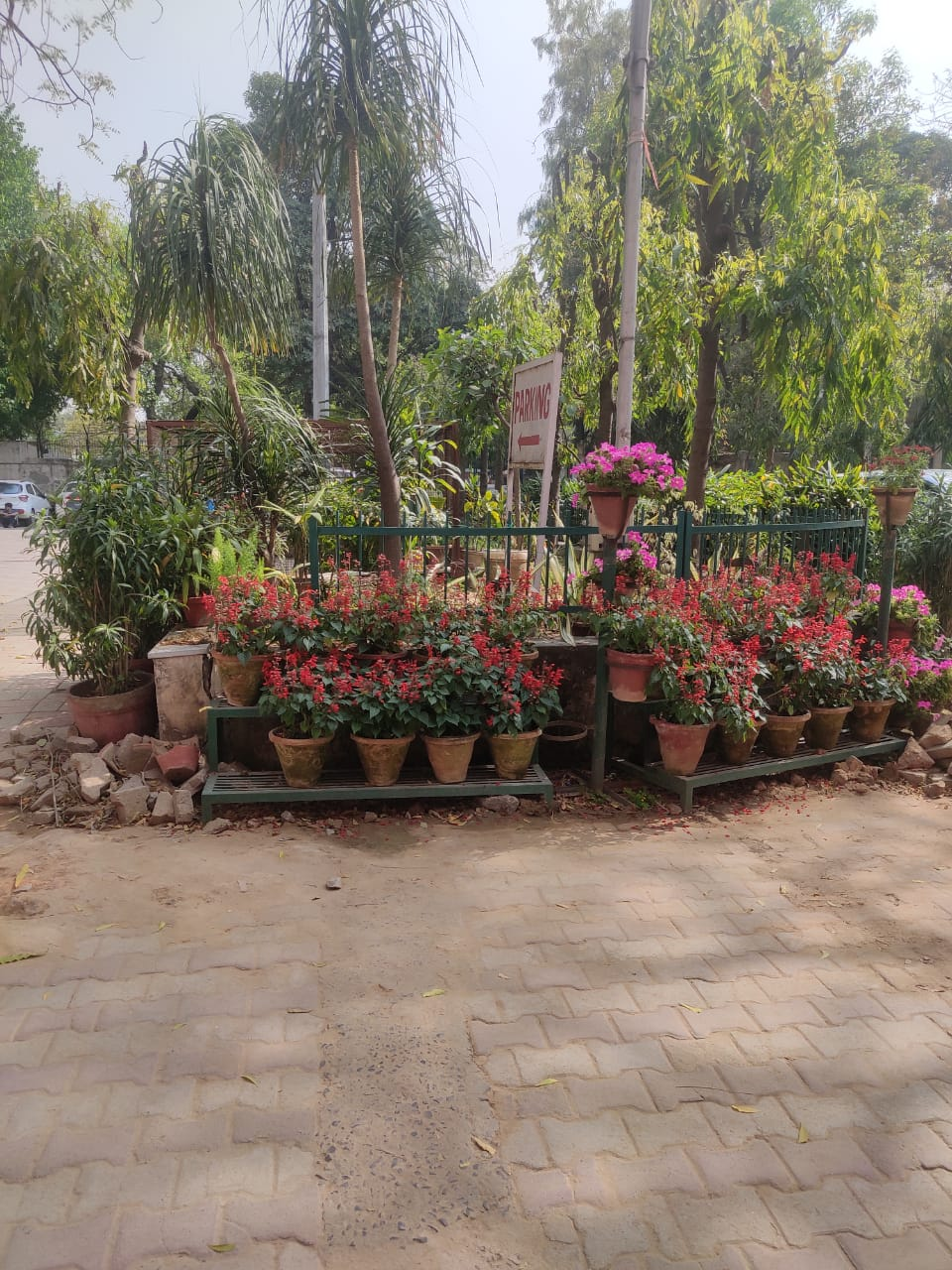 Flower & ornamental bed
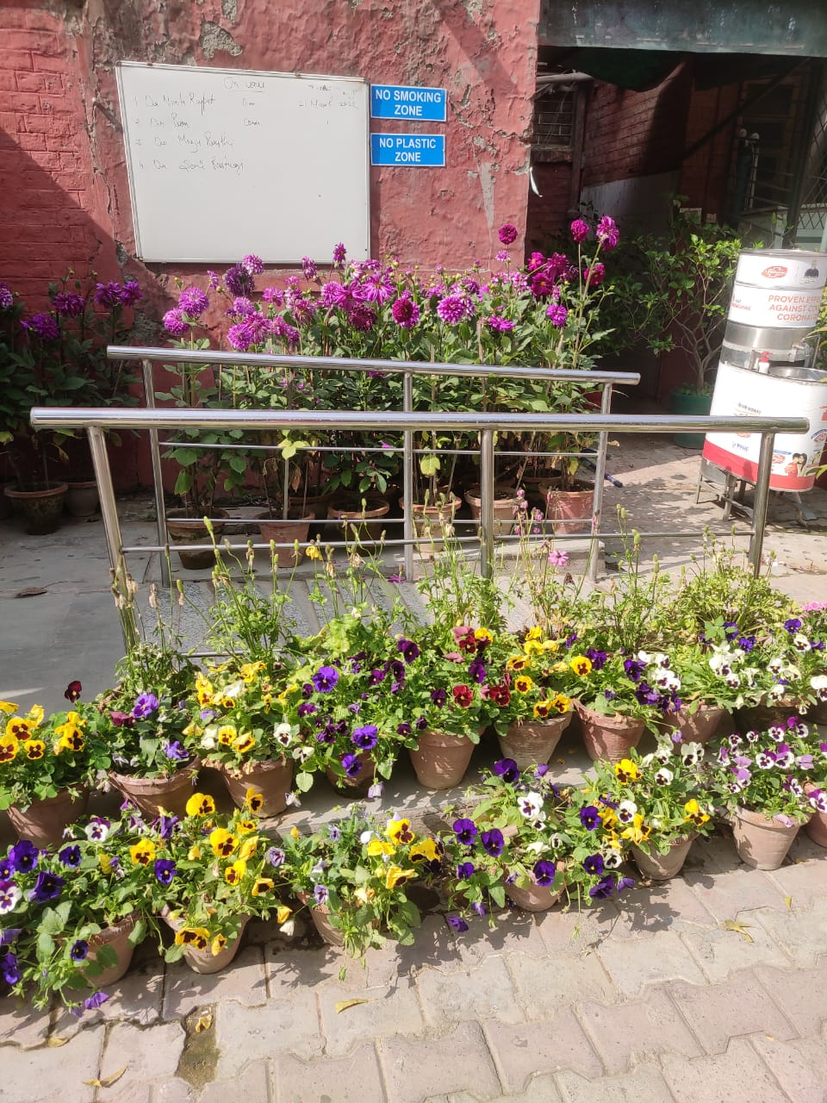 No Smoking /No Plastic Zone

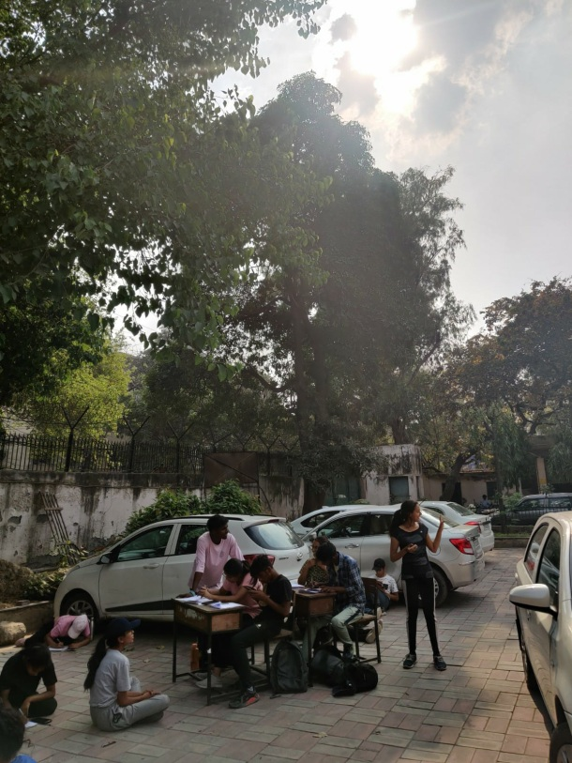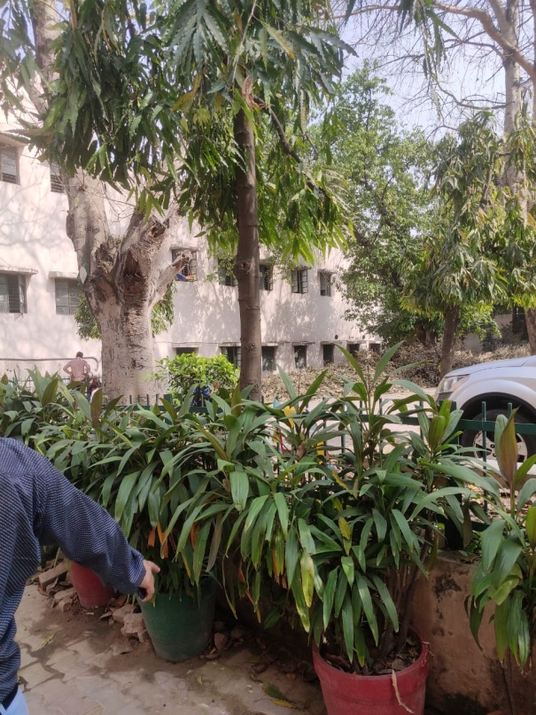

Peripheral trees, Shrubs & potted plants

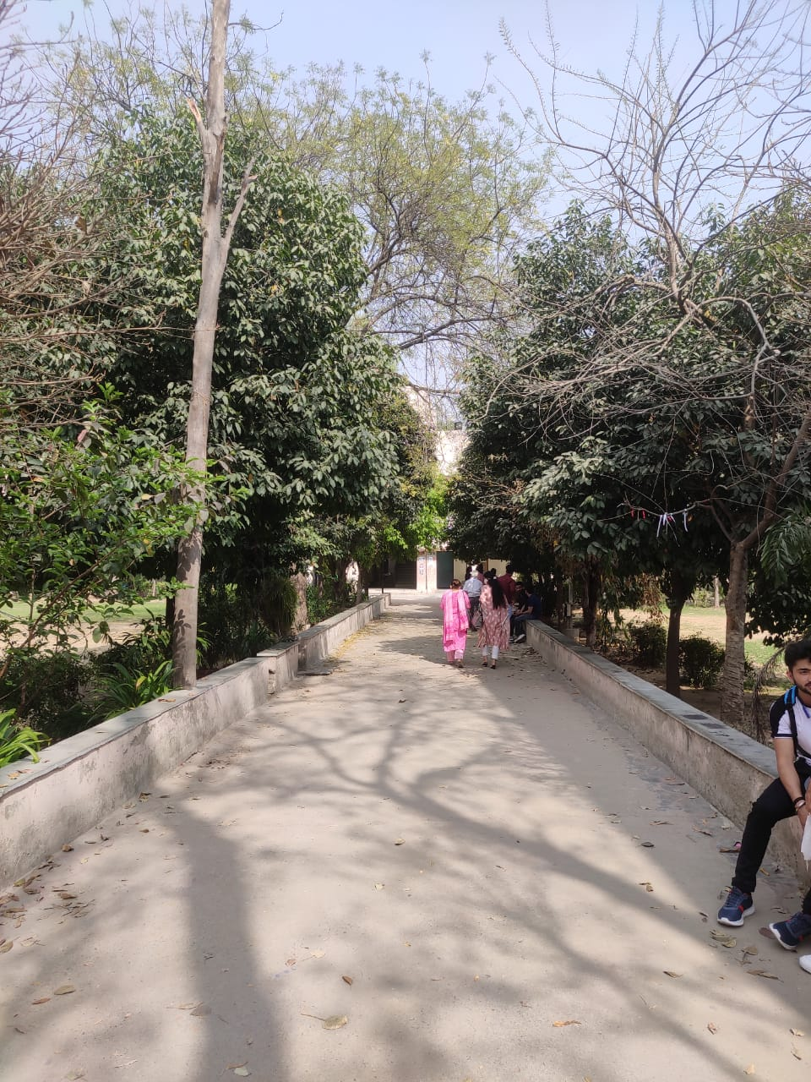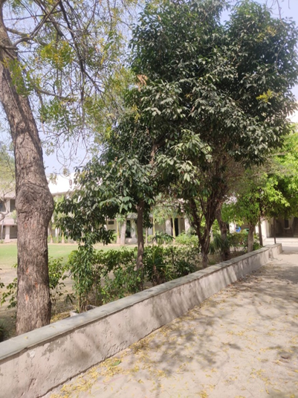
Pedestrian friendly pathway

Annexure 3: Roof top Solar panels –Real time photographs
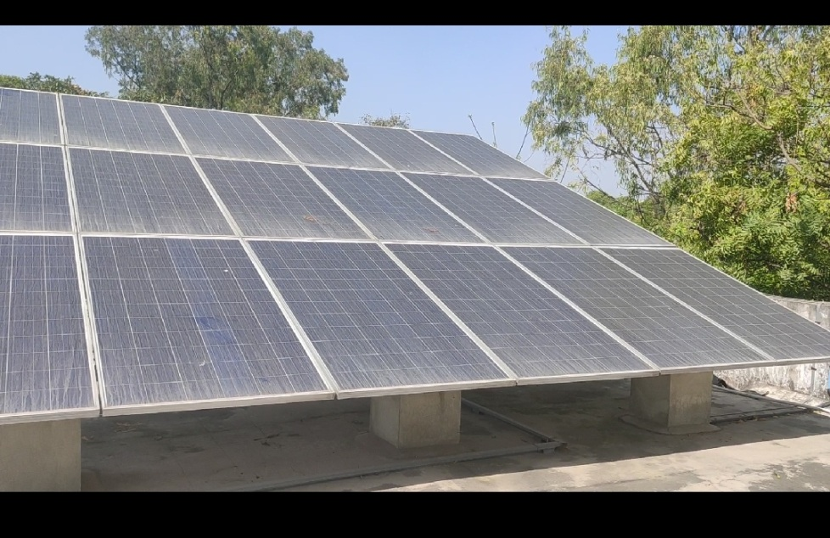

Annexure 4: Waste management- Bio gas plant

Functional Bio gas plant

Annexure 5: Waste Segregation & Composting
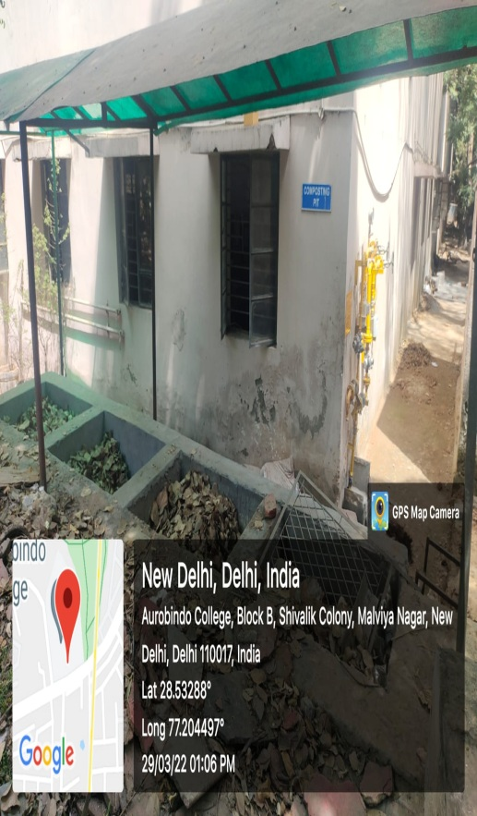
Vermicomposting
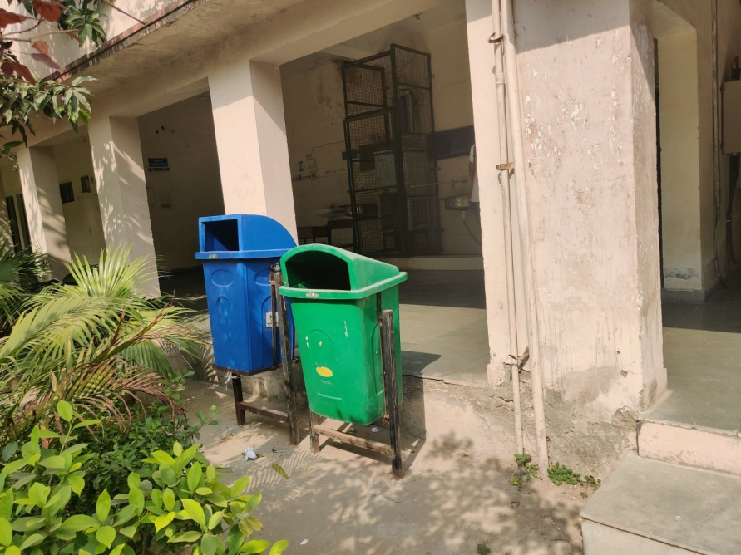
Waste segregation

Annexure 6: Water conservation practises

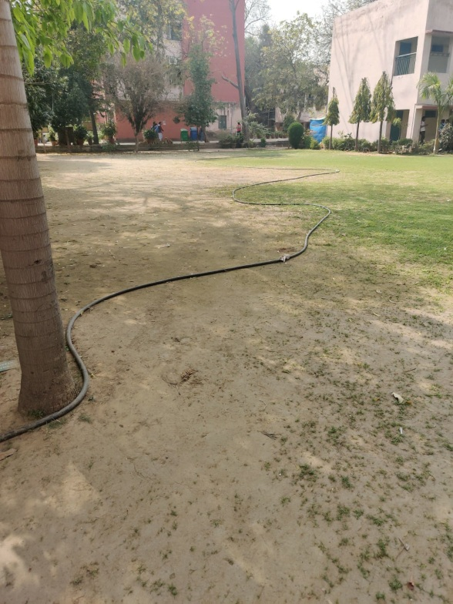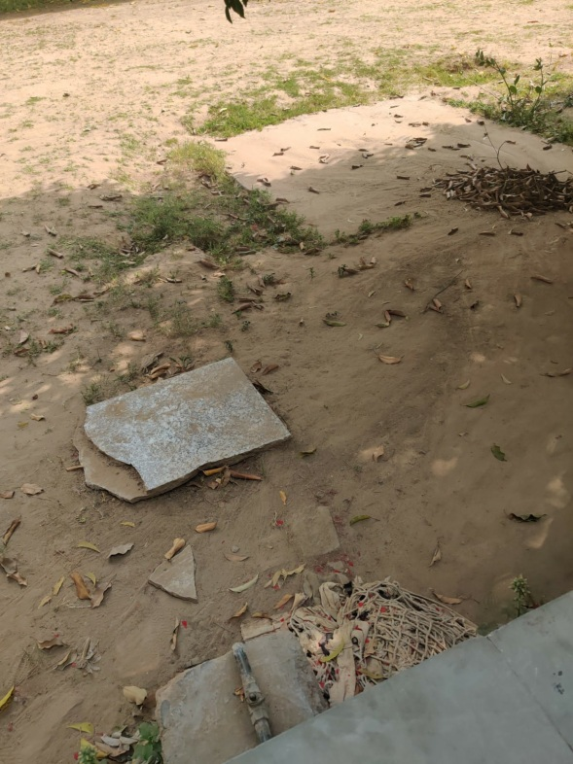
Drip irrigation Rain water harvesting pit

Annexure 7: Mandatory course –Environmental studies
